// Java code illustrating destroy()

// method for windows operating system

public class ProcessDemo

public static void main(String[] args)

{

try

{

// create a new process

System.out.println("Creating Process");

ProcessBuilder builder = new ProcessBuilder("notepad.exe");

Process pro = builder.start();

// wait 10 seconds

System.out.println("Waiting");

Thread.sleep(10000);

// kill the process

pro.destroy();

System.out.println("Process destroyed");

}

catch (Exception ex)

{

ex.printStackTrace();

}

}

}

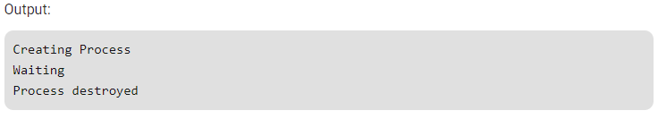

// Java code illustrating destroy()

// method for Mac Operating System

import java.lang.\*;

import java.io.\*;

class ProcessDemo

{

public static void main(String arg[]) throws IOException, Exception

{

System.out.println("Creating process");

//creating process

ProcessBuilder p = new ProcessBuilder(new String[]

{"open", "/Applications/Facetime.app"});

Process pro = p.start();

//waiting for 10 second

Thread.sleep(10000);

System.out.println("destroying process");

//destroying process

pro.destroy();

}

}

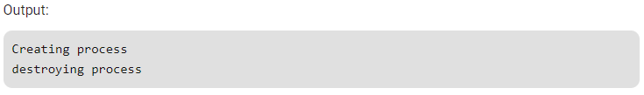

// Java code illustrating

// waitFor() method

public class ProcessDemo

{

public static void main(String[] args)

{

try

{

// create a new process

System.out.println("Creating Process");

Process p = Runtime.getRuntime().exec("notepad.exe");

// cause this process to stop

// until process p is terminated

p.waitFor();

// when you manually close notepad.exe

// program will continue here

System.out.println("Waiting over");

}

catch (Exception ex)

{

ex.printStackTrace();

}

}

}

